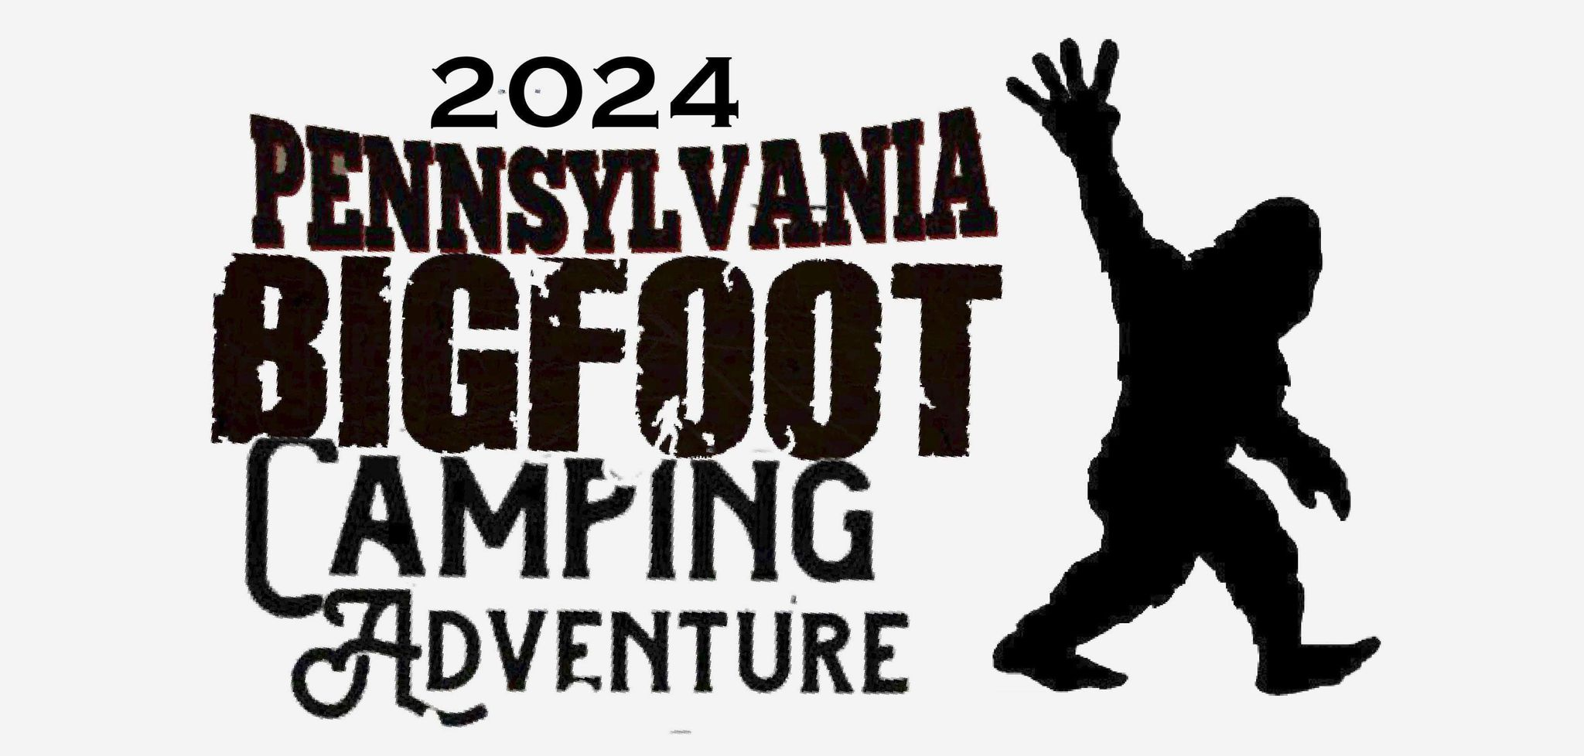

The Pennsylvania Bigfoot Society welcomes you to apply to join us for the 2024 Pennsylvania Bigfoot Camping Adventure!
Please read the following guidelines and conditions carefully before submitting your application.
- Please provide an up-to-date general listing/description of your merchandise. All vendors must be approved. No MLMs, resellers, or contractors.
- The space price is for two days: Friday, September 6 and Saturday, September 7, 2024.
- Set up time on the 6th is 12:45 PM. Set up time on the 7th is 8:45 AM. End time on both days is 8:00 PM
- Spaces are 10x10 feet at $50 each. Multiple spaces may be rented.
- Each space comes with a 6’ banquet table and two chairs. Space is limited. Any additional tables and/or chairs must be provided by the vendor if desired.
- Any shade pavilions or EZ Ups must be brought and set up by the vendor.
- Electricity is not available.
- Initial access to vendor spaces on Friday will begin at 11:45 AM. There will be no prior access to the site.
- Vendors must be set up and ready for business no later than 1:45 PM on Friday and 9:45 AM on Saturday, 15 minutes before the site opens for the day.
- No parking of trailers or motor vehicles on the main field during event hours.
- All vendors must set up in the designated area.
- Before departure on Saturday, vendor areas must be cleared of trash.
- Neither the Pennsylvania Bigfoot Camping Adventure nor the Pennsylvania Bigfoot Society assumes responsibility for weather and/or ground conditions or any other business operating restrictions.
All applicants are subject to approval by the 2024 Pennsylvania Bigfoot Camping Adventure staff, based on predetermined criteria, which includes space availability and the ability to adhere to the above guidelines. Please complete the enclosed application form and return it to the Pennsylvania Bigfoot Camping Adventure before Friday, July 15th, 2024. Vendors will be notified of the determination by phone and/or email.
The total registration fee is due upon APPROVAL of this application. Registration fees are nonrefundable. Registration fees can be in the form of a check or money order payable to: [Eric H Altman]."
And Mailed to: 4110 Cambridge Dr., Irwin PA 15642
Thank you for your interest in attending the 2024 Pennsylvania Bigfoot Camping Adventure!

Business Information
Business/Organization Name: ____________________________________________________
Point of Contact Name: _________________________________________________________
Address: _____________________________________________________________________
Telephone: _________________________ Email: __________________________________
Social Media and/or Website: _____________________________________________________
General merchandise list/description: ________________________________________________

Fee Information
$50 x (number of spaces) ________________ = $ _____________________ (Total)
Please keep in mind that space is very limited and may fill up quickly.
If you have any additional details to include, please attach them to the application. Also, if necessary, provide a general merchandise list/display description on the back of this application.
The total registration fee is payable upon APPROVAL of this application. Registration fees are nonrefundable.

